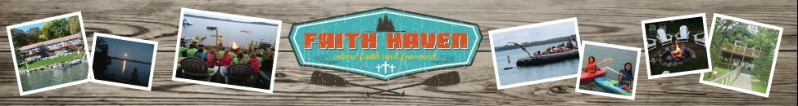
STAMP, SCRAP, QUILT & CRAFT RETREAT
Come for the Extended Weekend!
Come for Saturday!
- Bring projects!
- Relax, & rejuvenate!
•Learn new techniques!
•MANY stamps, gadgets to use & ideas to copy
•Bring a snack to share

April 11-14, 2024

Name: _________________________________________
Address: _______________________________________
_______________________________________________

Phone: _________________________________________
Email: __________________________________________
FAITH HAVEN CAMP
38360 N EAGLE LAKE RD BATTLE LAKE, MN 56515
Call #218-864-5303 email: faithhavencamp@gmail.com

Saturday Only: $50_______
This includes Breakfast (8:30 a.m.) Beverages, Dinner and a Stamping Class (materials) with Gloria Flaten: Stampin’ Up Demonstrator. Stay all day to work on your projects!
Weekend: Fri-Sun $100_______ Includes all above plus–, lodging both nights (bring your own bedding, towels and toiletries) & breakfast & light lunch on Sunday– project area open until 4 p.m.
Extended Weekend: Thursday Afternoon/Evening Arrival-Sun-$120______
